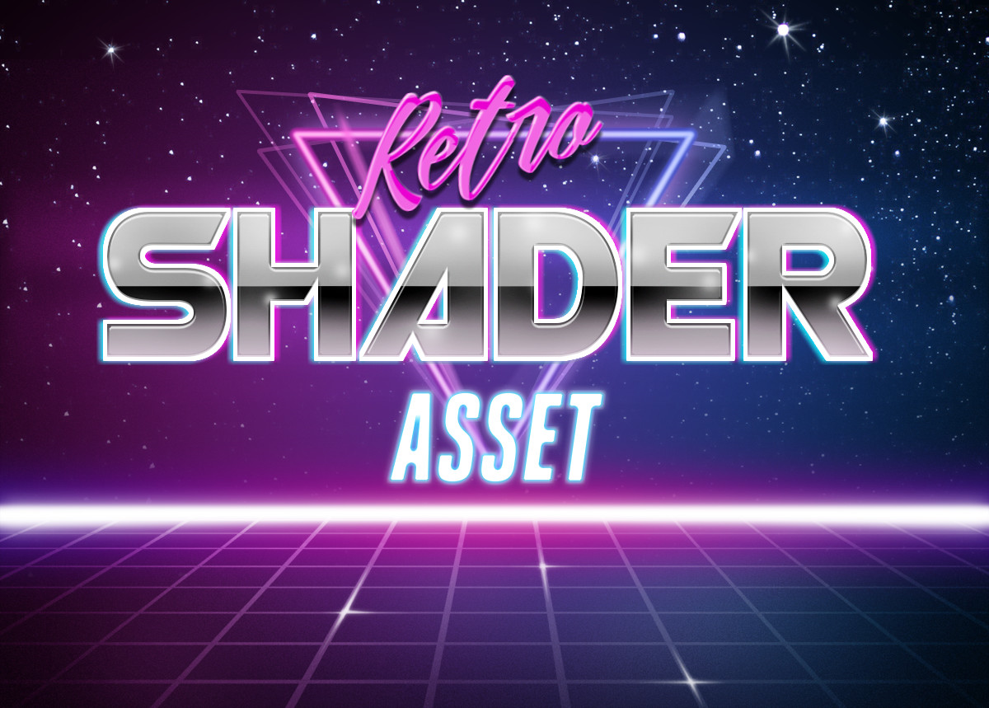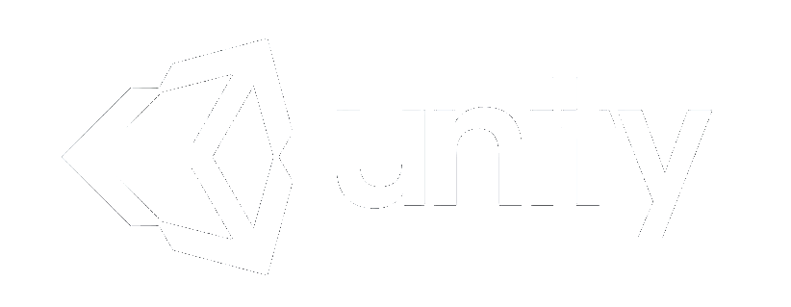

**Documentation**

**by cartridgegamestudio**

***What is this?***

This is a simple Shader asset for creating Retrowave style objects in Unity. You can apply this shader to anything you want. Yes, even to Terrains!

It comes with a demo scene that includes a retro car and palm models.

In normal state, they are not looking as glamorous as you expect, so don’t forget to support it with a Bloom effect.

***Usage of Shader***

Just use pre-created materials or create a new material. From Shader tab, click Retro and then select Retro Shader. Congrats, now you have your own retro material.

**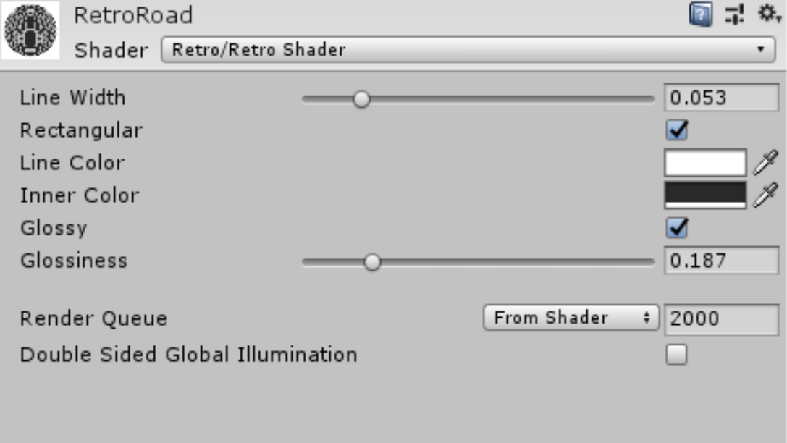*Shader Details***

**Line Width:** This is for setting the line width. Sometimes you may want to scale this up to get stronger wireframe effect.

**Rectangular:** This is for telling shader to create rectangular wireframe or basic triangular wireframe. In general, its always set to True. But if you have more funky effects on your mind, feel free to set this off.

**Line Color:** This is for setting the wireframe’s line color. This is the main part where all retro feel comes.

**Inner Color:** This is for setting the inner color of the object. In retro game, its always either black or black-ish color. But hey, its your imagination, you can make it whatever you like.

**Glossy:** This is for telling Shader whether its glossy or not. If you select Glossy, it will reflect the outer objects around it. You need a probe for better experience.

**Glossiness:** This is for adjusting the level of glossiness. Sometimes too shiny materials look bad.

**Rest:** These are from Unity’s side. You can change them if you know what you are doing.

**Notes**

Feel free to use any Scripts inside the Asset folder for any purpose.

I don’t recommend anyone to use Demo Models for Commercial purpose. Because they are coming inside the asset, they can be used by anyone which will result a bad quality for your Game/Software having a shared identical property with other Game/Software in the market.

**Credits**

*Bloom Effect from genius Keijiro’s github - https://github.com/keijiro/KinoBloom/releases*

**Contact**

If you have any questions – requests or bug reports, you can contact to me from [cartridgegamestudio@gmail.com](mailto:cartridgegamestudio@gmail.com) whenever you want. I usually check my emails so I probably will give an answer as soon as possible.